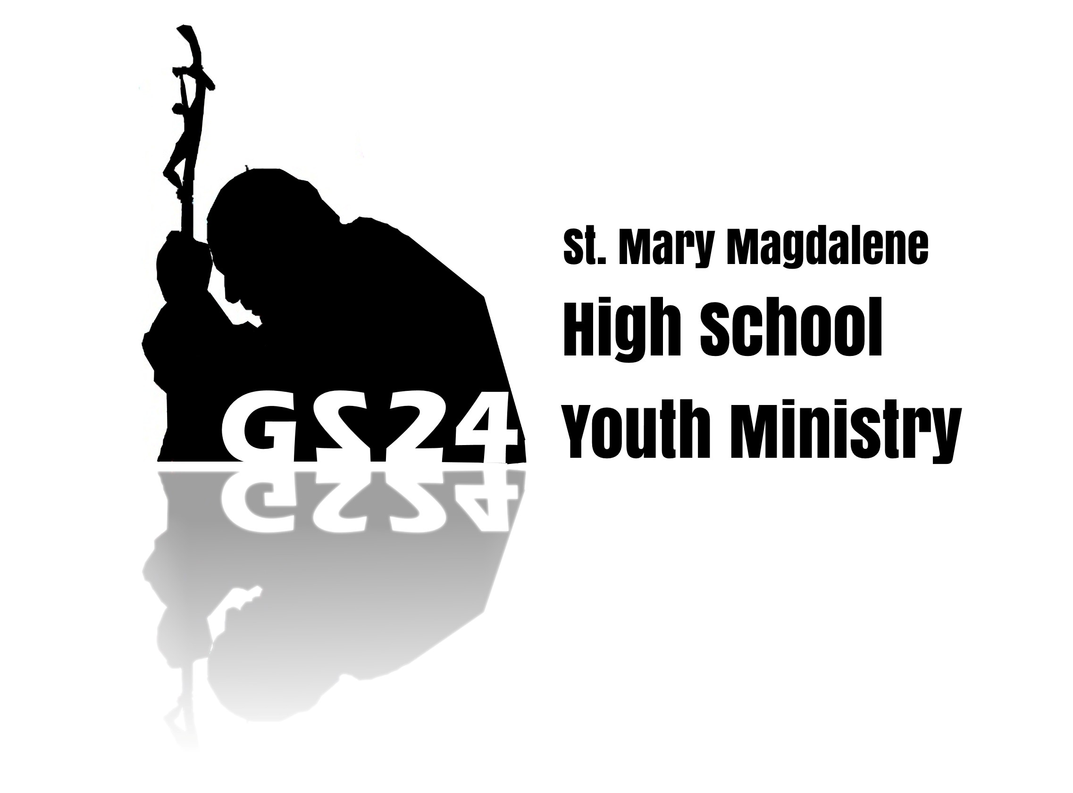
Follow us!
Twitter: @smarymagteens
Instagram: @smarymag_teens
Blog: rippleeffect24.wix.com/rippleeffect

Today’s Date: __ /__ /__

“Man…cannot fully find himself, except through a sincere gift of himself”
- Gaudium et Spes, 24

Teen I nform a t i on
Teen Full Name: _________________________________ Birth Date: ___/___/___ Grade:________ T-Shirt Size: S M L XL 2XL 3XL Gender: F M School: _____________________________ Teen Cell: (______) ______________ Permission to receive Texts from Parish Phone? Y N
Teen E-mail: _________________________________________________________________________ Hobbies: ____________________________________________________________________________
_____________________________________________________________________________________

_____________________________________________________________________________________

_____________________________________________________________________________________ Are you baptized? Y N In the Catholic Church? Y N
Have you received your first Reconciliation? Y N First Communion? Y N Have you been confirmed in the Catholic Church? Y N

Teen A g r eement
I agree to abide by any and all rules communicated to me for any GS24 nights and events. If I fail to maintain the guidelines and expectations of the adults and my peers, I understand that there will be consequences for my actions, including being removed from the activity and being sent home at my parent’s expense. Basic rules/expectations include, but are not limited to the following: Respect for all adult leaders, peers, and all property; NO illegal drugs,
alcohol, underage smoking, firearms, explosives, or other illegal substances; Males and females
are to remain in separate sleeping spaces at all times; No inappropriate physical/sexual activity; Appropriate, modest attire is to be worn at all times.

Teen Signature: ______________________________________________________________________
Med i a R e l e a s e F o r m
Photographs and videos will be taken of youth ministry events and gatherings. We would like to be able to use these photographs and videos for fliers, parish and diocesan publications, the parish website and the GS24 social media accounts. Written consent of both the teen and a parent/guardian is required. Names will not be posted unless written authorization is given by the student and a parent/guardian, and even then, only first names will be used. If there are any concerns about pictures or videos used on- line, please contact Jake Stanley and they will be promptly removed.
I/We, the undersigned parent(s)/Guardian(s) of , authorize
and give full consent, without limitation or reserve, to St. Mary Magdalene Parish to publish any photograph or video in which the above named teen appears while participating in any youth ministry event. There will be no compensation for use of any photograph or video at the time
of the publication or in the future.

Teen Signature: ___________________________________________________ Date: ___/___/___ Parent/Guardian Signature: _________________________________________ Date: ___/___/___ Parent/Guardian Signature: _________________________________________ Date: ___/___/___

Teen M edi c a l I nfo:
Teen’s Doctor’s Name:____________________________ Doctor’s Phone: (___ )_______________ Insurance carrier: _______________________ Insurance Phone: (___ )_______________ Policy #:__________________________________________Group #:___________________________ Emergency Contact Name and relation to you: _______________________________ Emergency Contact Phone #: ______________________________________________________
Please list any allergies, dietary/medical/physical restrictions, or prescription medications.

Par ent I nform a t i on
Father’s Full Name:_ Father’s Cell #: (____)______________ Mother’s Full Name:_ Mother’s Cell #: (____)______________
Father’s E-mail:_

Mother’s E-mail:_ Teen Lives with (circle one): Both Parents Mother Father Other:_________________ Teen Address: ________________________________
_____________________________________________________________________________________
Parent Agreement
We do not charge a fee for participation in GS24. Because of this, we ask for your generosity in order to continue providing for the needs of our teens. Please consider any of the following:
☐ I would like to register as a driver for special events, as needed (SET class required).
☐ I would like to help provide snacks and/or meals for GS24 nights.
☐ I would like to serve as a core member for GS24 (SET class & interview required).
☐ I would like to contribute to our Retreat Scholarship Fund.
Amount $ _________________
☐ I would like to contribute to our Summer Camp Scholarship Fund.
Am o u n t $ _________________
☐ I would like to contribute to our DC March for Life Pilgrimage Scholarship Fund
Am o u n t $ _________________
*Please make checks payable to “St. Mary Magdalene” with the appropriate scholarship fund indicated on the subject line

Liabi l i t y R e l e ase
We, the parent(s)/guardian(s) of _______________________________, do hereby give my/our permission and approval for my/our son/daughter/guardianship to participate on St. Mary Magdalene Parish’s GS24 Program during the present school year. I/ We do hereby, for myself, my heirs, executors, and administrators, waive, release, absolve, indemnify and agree to hold harmless any and all staff, chaperones, other participants, the parish of St. Mary Magdalene, the Catholic Diocese of Phoenix, GS24, and any of the above named parties’ representatives, successors, supervisors, sponsors, and/or organizers, for any injuries in
connection with the outing / event(s) named above provided that said injuries are not the result of negligence. I/We give permission to seek any emergency care should my child be involved
in any accident or be injured in any way during such events named above. I/We understand
that in any such instance, all attempts will be made to contact the parent/guardian. In the
event that I/we cannot be contacted, I/we hereby give permission to the attending physician to hospitalize, secure treatment for, and to order injection, anesthesia, and/or surgery for my
child, as named herein.
I also agree that I am legally responsible for all/any personal actions taken by my child/guardianship during this event, and agree to be financially responsible for any/all damages, legal fees, and other costs incurred as a result of the actions/behavior of my child/guardianship.
Furthermore, I/we agree that if the above named teen’s behavior is inappropriate, unsafe and/or detrimental to the group, I will be contacted immediately to secure means of removing my child/guardianship from the event premises. I understand that any financial costs incurred as a result of my child/guardianship being sent home are my responsibility.

Parent/Guardian Signature: _____________________________________ Date:___/___/___

